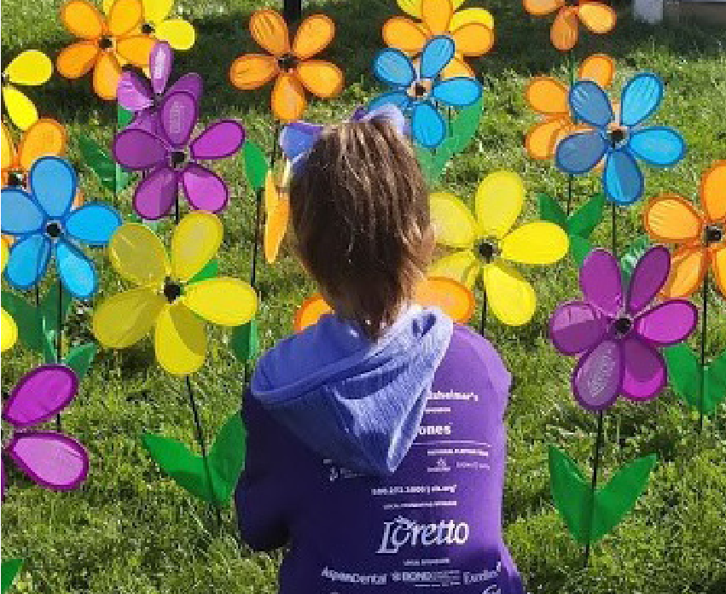

THE END OF ALZHEIMER’S STARTS WITH
[NATIONAL TEAM NAME]

Join our 2021 Walk to End Alzheimer’s® National Team.
The Alzheimer’s Association Walk to End Alzheimer’s® is the world’s largest event to raise funds and awareness for Alzheimer’s care, support and research.
Join [Team Name] in the fight against the disease by registering today for an event near you.

[URL]
[DATE]
[Event details here] [Event details here]

