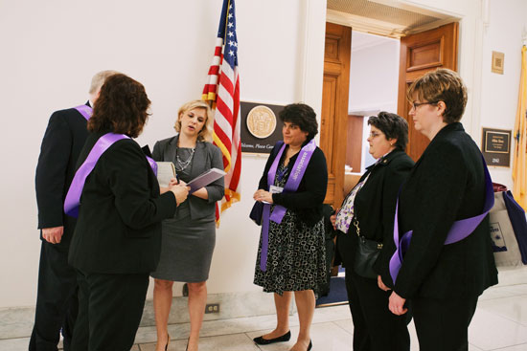
What is an Advocate?
Alzheimer's Advocates play an important role in improving the quality of care and quality of life for people with Alzheimer’s disease and their families by carrying our message to elected officials at the federal, state and local levels.
As an Advocate, you will be invited to:
- Receive regular updates about current legislative and public policy issues.
- Communicate with elected officials via emails, petitions, phone calls and other calls-to-action.
- Participate in advocacy and policy-related events.
- Share your story with other Advocates.

Get involved today!
Join the National Alzheimer Advocate Network.

Whoever you are,
wherever you live,
you can make a difference.
Sign up at www.alz.org/advocate

For more information, contact Jaimie Randall
jrandall@alz.org
800-272-3900 (during regular business hours)

